NAME: CHRISTINA JOSE MANAKKAL

ROLL NO: 48 TEITB PID: 191064

St. Francis Institute of Technology, Mumbai-400 103

**Department Of Information Technology**

A.Y. 2021-2022

Class: TE-IT B, Semester: V

Subject: **DevOps Lab**

**Experiment – 1: To understand DevOps: Principles, practices and DevOps Engineer role & responsibilities and learn basic Linux commands**

1. **Aim:** To prepare case study on DevOps and execute Linux commands
2. **Objectives:** After study of this experiment, the students will be able to
   * Understand the fundamentals of DevOps engineering and be fully proficient with DevOps terminologies, concepts, benefits and deployment options to meet business requirements
   * Demonstrate execution of Linux commands
3. **Outcomes:** After study of this experiment, the students will be able to
   * Understand the importance of DevOps thoroughly
   * Demonstrate the Linux commands
4. **Prerequisite:** Knowledge of software engineering and project management basic principles
5. **Requirements:** Personal Computer, Windows operating system, Ubuntu Operating system or any online terminal, Internet Connection, Microsoft Word.
6. **Pre-Experiment Exercise:**

**Brief Theory:** Refer shared material

1. **Laboratory Exercise**
   * + 1. **Procedure:**

**a.** Prepare case study based on following:

* Introduction

DevOps is the combination of cultural philosophies, practices, and tools that increases an organization’s ability to deliver applications and services at high velocity: evolving and improving products at a faster pace than organizations using traditional software development and infrastructure management processes. This speed enables organizations to better serve their customers and compete more effectively in the market.

* Need

Software and the Internet have transformed the world and its industries, from shopping to entertainment to banking. Software no longer merely supports a business; rather it becomes an integral component of every part of a business. Companies interact with their customers through software delivered as online services or applications and on all sorts of devices. They also use software to increase operational efficiencies by transforming every part of the value chain, such as logistics, communications, and operations. In a similar way that physical goods companies transformed how they design, build, and deliver products using industrial automation throughout the 20th century, companies in today’s world must transform how they build and deliver software.

* Usage

DevOps proponents describe several business and technical benefits, many of which can result in happier customers. Some benefits of DevOps include:

Faster, better product delivery

Faster issue resolution and reduced complexity

Greater scalability and availability

More stable operating environments

Better resource utilization

Greater automation

Greater visibility into system outcomes

Greater innovation



* DevOps Lifecycle



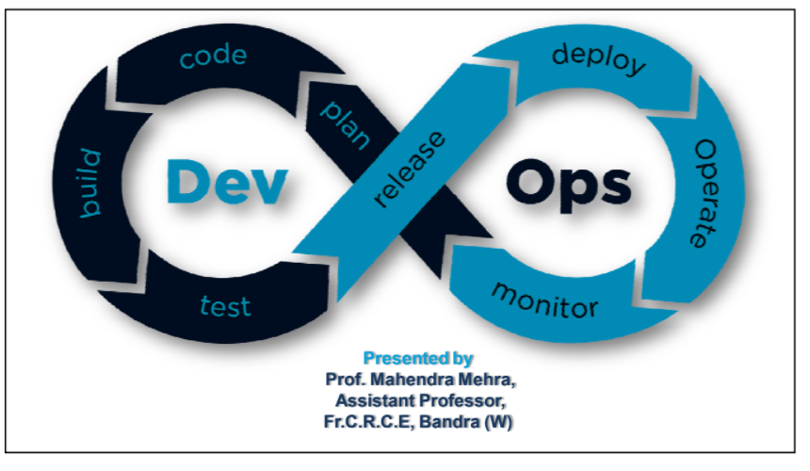



* Advantages and disadvantages



o Advantages:

1. Ensure faster deployment.

2. Stabilize work environment.

3. Significant improvement in product quality.

4. Automation in repetitive tasks leaves more room for

innovation.

5. Promotes agility in your business.

6. Continuous delivery of software.

7. Fast and reliable problem-solving techniques.

o Disadvantages:

1. DevOps professional or expert developers are less

available.

2. Developing with DevOps is so expensive.

3. Adopting new DevOps technology into the industries is

hard to manage in a short time.

4. Lack of DevOps knowledge can be a problem in the

continuous integration of automation projects.

**b**. **Enlist following Linux commands with their explanation and execution screenshots**

1. Sudo

sudo (SuperUser DO) Linux command allows you to run programs or

other commands with administrative privileges, just like “Run as



administrator”in Windows. This is useful when, for example, you need

to modify files in a directory that your user wouldn’t normally have

access to.

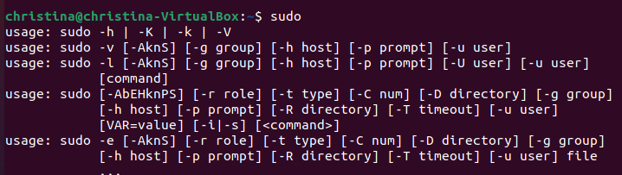

1. Apt -get

The Advanced Package Tool, Or ‘APT’ for short, is the package management

service for Ubuntu and Debian based systems. The apt command is

responsible for installing, updating, removing, and managing packages of

Ubuntu and Debian based systems.

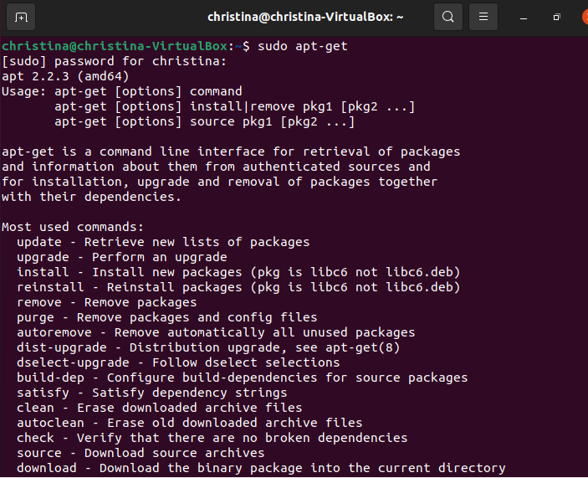

Sudo apt-get update

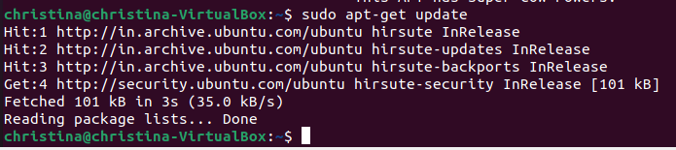

1. Ls

ls (list) command lists all files and folders in your current working

directory. You can also specify paths to other directories if you want

to view their contents.



1. Cd

cd (change director”) Linux command also known as chdir used to

change the current working directory. It’s one of the most used basic

Ubuntu commands. Using this command is easy, just type cd followed

by the the folder name.



1. Pwd

pwd (print working directory) Ubuntu command displays the full

pathname of the current working directory.

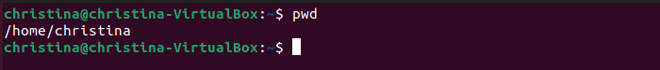

1. Cp

Cp stands for copy. This command is used to copy files or group of

files or directory. It creates an exact image of a file on a disk with

different file name.

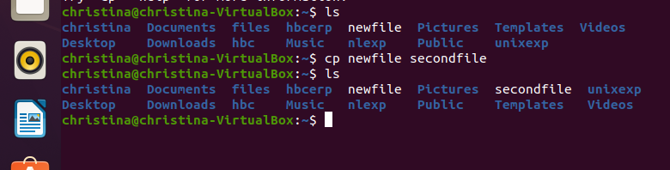

1. Mv

mv (move) command allows you to move files. You can also rename

files by moving them to the directory they are currently in, but under a

new name.

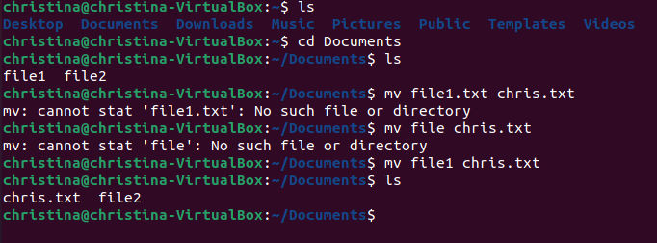

1. Rm

rm (remove) command removes the specified file.

rmdir (“remove directory”) – Removes an empty directory.

rm -r (“remove recursively”) – Removes a directory along with its

content.

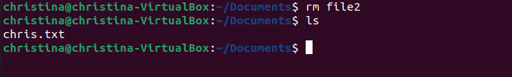

1. Mkdir

mkdir (make directory) command allows you to create a new directory.

You can specify where you want the directory created – if you do not

do so, it will be created in your current working directory.

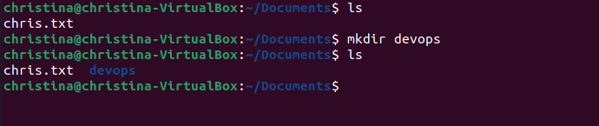

1. History

history command displays all of your previous commands up to the

history limit.

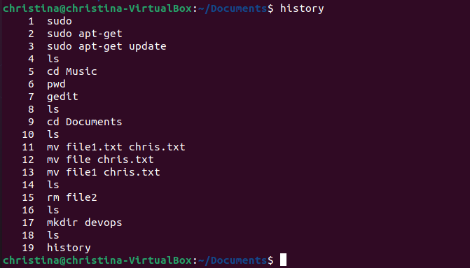

1. Df

df (display filesystem) command displays information about the

disk space usage of all mounted filesystems.

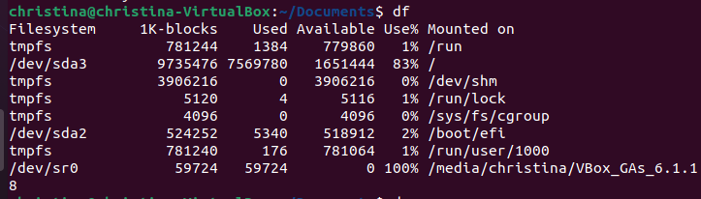

1. Du

du (directory usage) command displays the size of a directory and all

of its subdirectories.

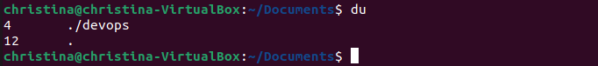

1. Free

free – Displays the amount of free space available on the system.

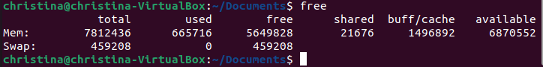

1. Uname -a

uname -a – Provides a wide range of basic information about the

system.



1. Top

top – Displays the processes using the most system resources at any

given time. “q” can be used to exit.

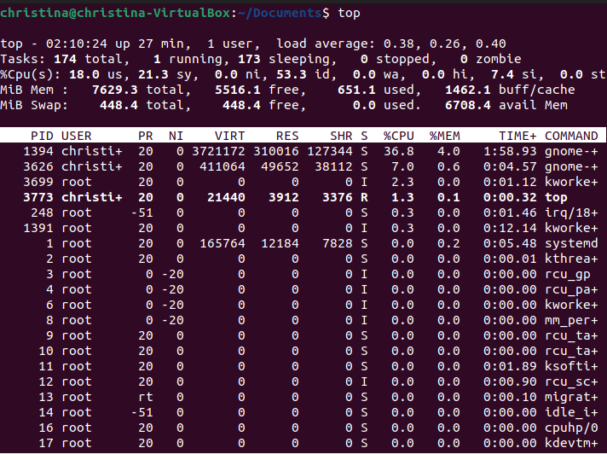

1. Man

man command displays a “manual page”. Manual pages are

usually very detailed.

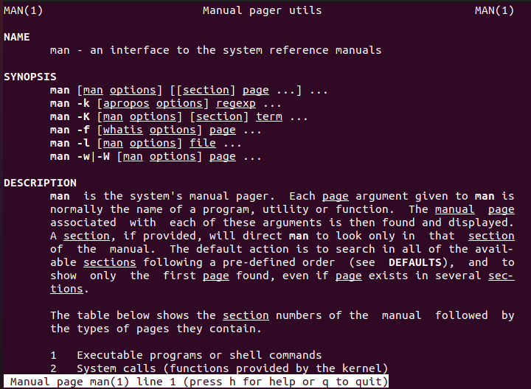

1. Info

Info command reads documentation in the info format. It will give

detailed information for a command when compared with the man

page. The pages are made using the texinfo tools because of which it

can link with other pages, create menus and easy navigation.

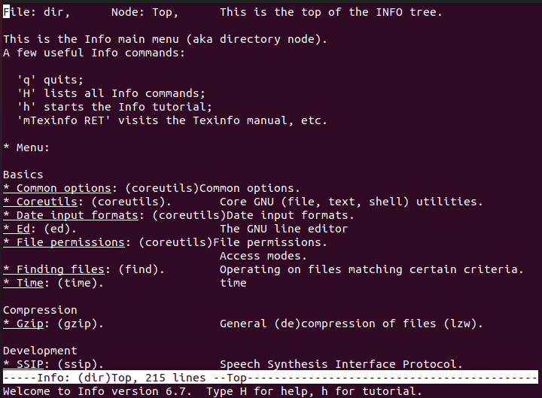

1. Passwd

Info command reads documentation in the info format. It will give detailed

information for a command when compared with the man page. The pages

are made using the texinfo tools because of which it can link with other

pages, create menus and easy navigation.

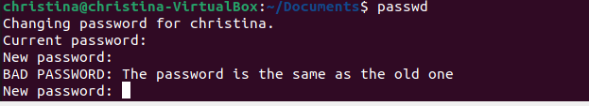

1. Whatis

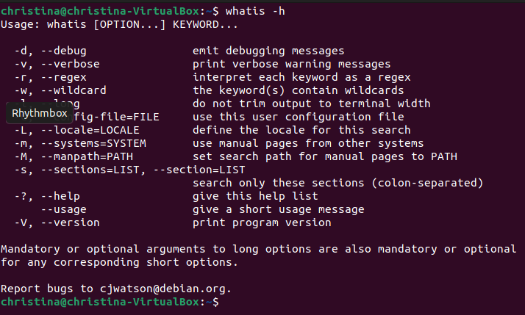

1. Date

The date command is used to display the system date and time. date

command is also used to set date and time of the system. By default the

date command displays the date in the time zone on which unix/linux

operating system is configured.



1. W

The w command lists the currently logged in users.

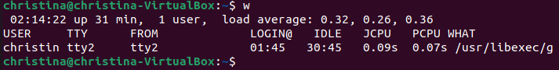

1. Exit

The exit command will close a terminal window, end the execution of a

shell script, or log you out of an SSH remote access session.



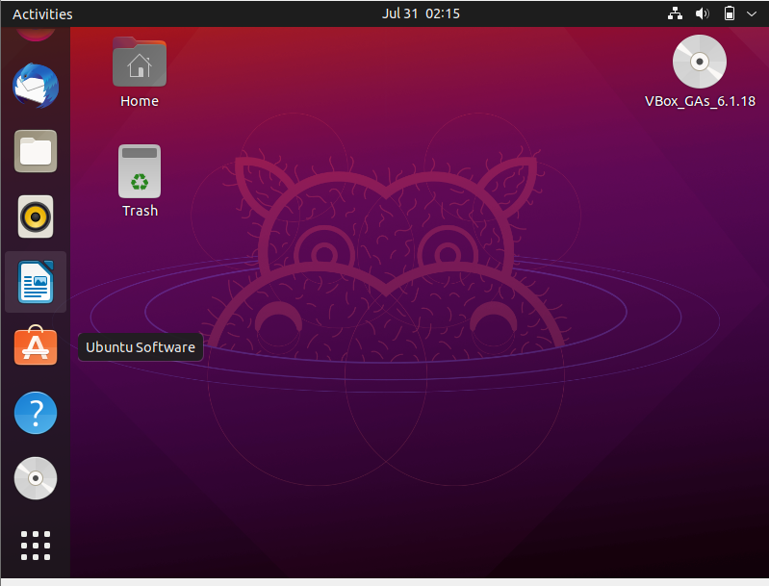

1. Shutdown

The shutdown command lets you shut down or reboot your Linux system.

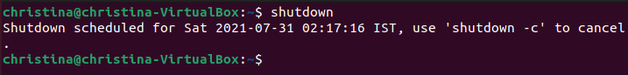

1. Head

The head command gives you a listing of the first 10 lines of a file. If you

want to see fewer or more lines, use the -n (number) option.

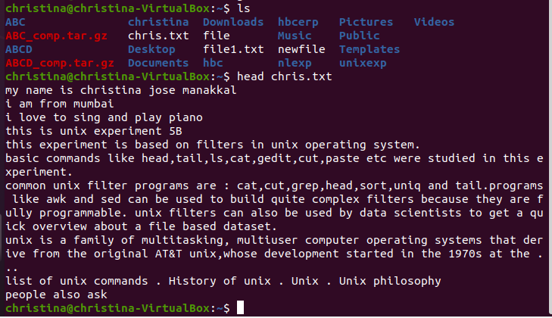

1. Tail

The tail command gives you a listing of the last 10 lines of a file. If you

want to see fewer or more lines, use the -n (number) option.

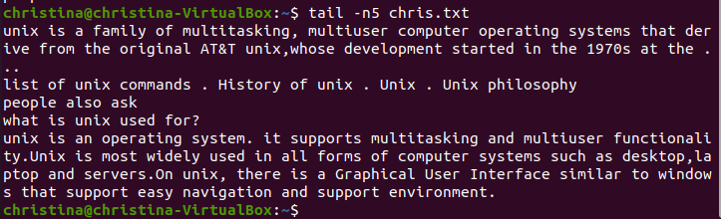

1. Echo

The echo command prints a string of text to the terminal window.

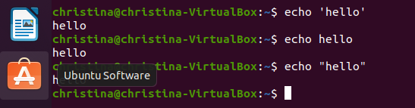

1. Grep

The grep utility searches for lines which contain a search pattern. When

we looked at the alias command, we used grep to search through the output

of another program, ps . The grep command can also search the contents of

files. Here we’re searching for the word “Blockchain” in all text files

in the current directory

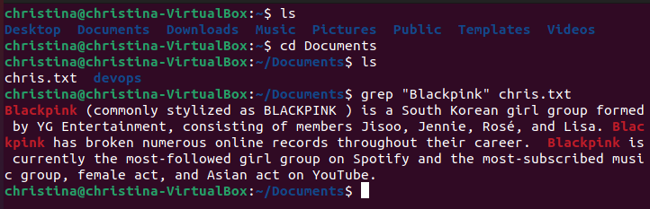

1. Zip

ZIP is a compression and file packaging utility for Unix. Each file is stored

in single .zip {.zip-filename} file with the extension .zip.

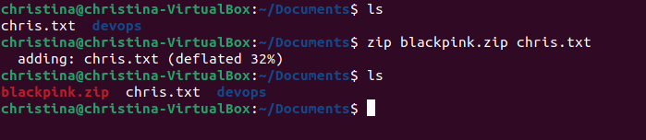

1. Unzip

This command unzips the zip file , The basic syntax for decompressing a

file is unzip filename.

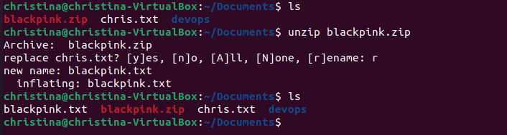

1. <command name> -h or <command name> –help

-h stands for help, if the user is new to the command he/she can use this

after command then they can read the documentation of the command how

to use that.

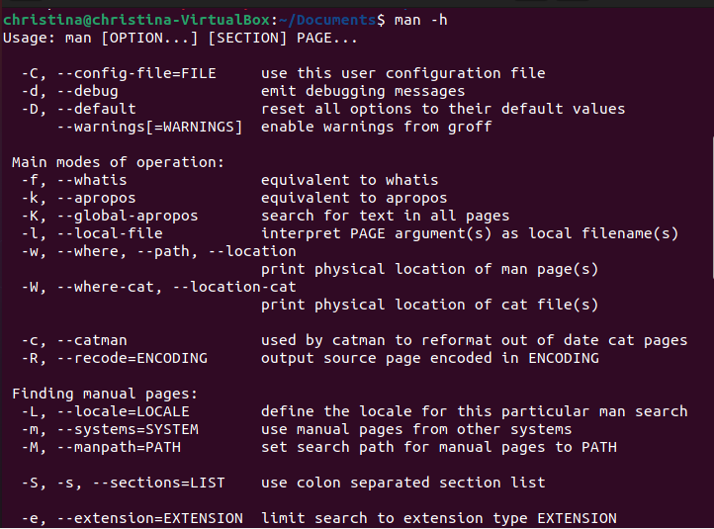

1. **Post-Experiments Exercise**
2. **Extended Theory:**

Nil

1. **Questions:**

* What is Linux and basic components of Linux?
* What are the shells used in Linux?
* What are the top 10 devops tools that are used in the industry today?
* How will you approach when a project needs to implement devops?

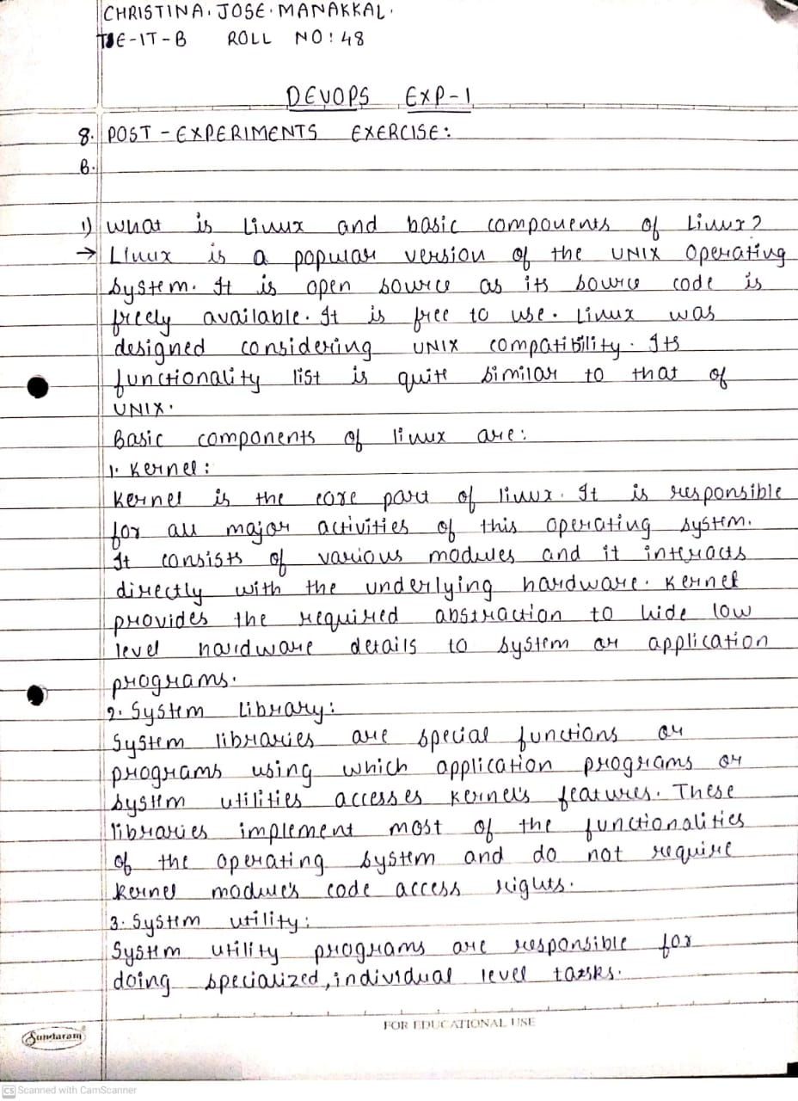

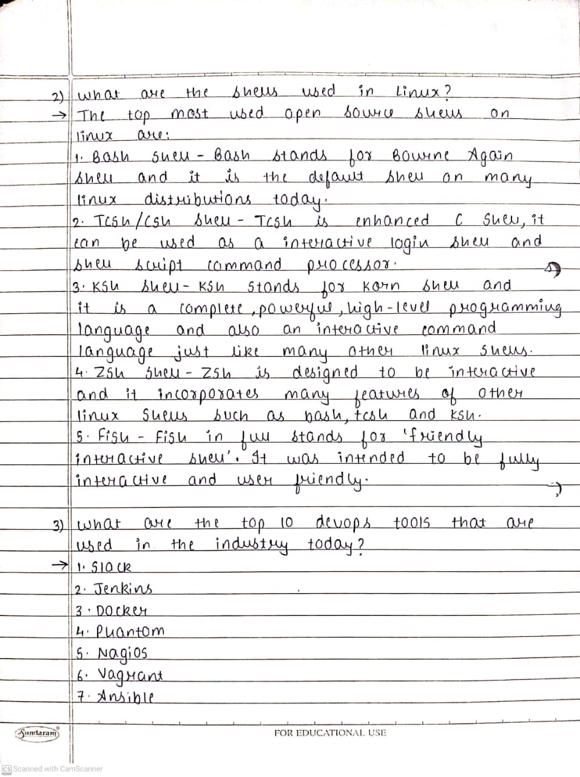

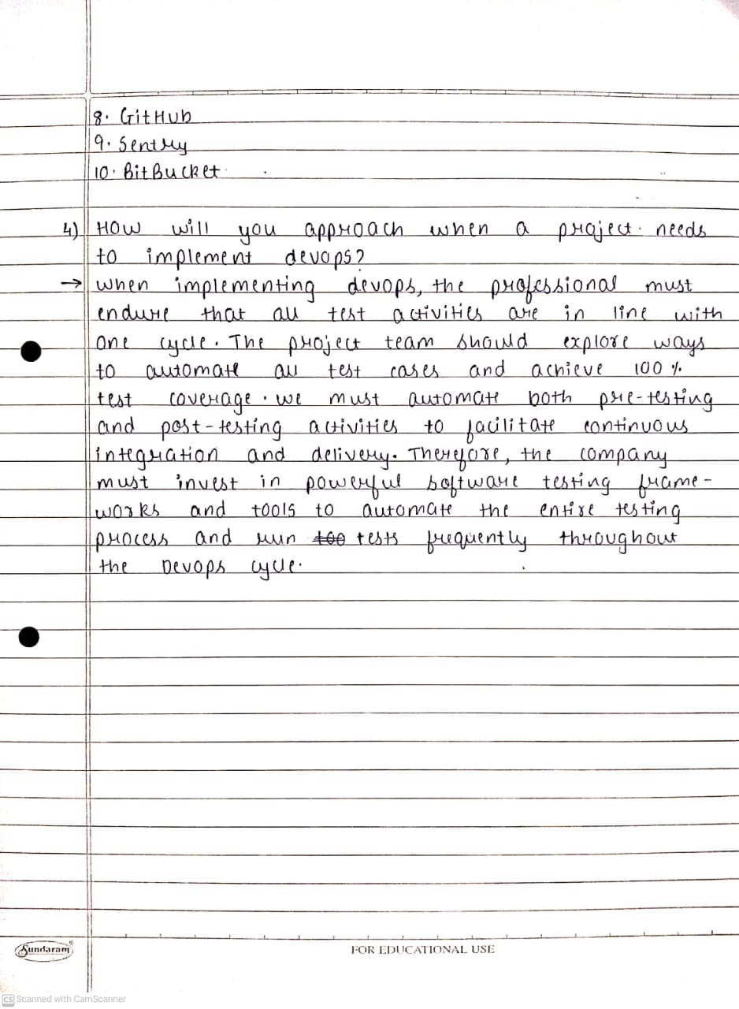

1. **Conclusion:**

* Write what was performed in the experiment.
* Write the significance of the topic studied in the experiment.

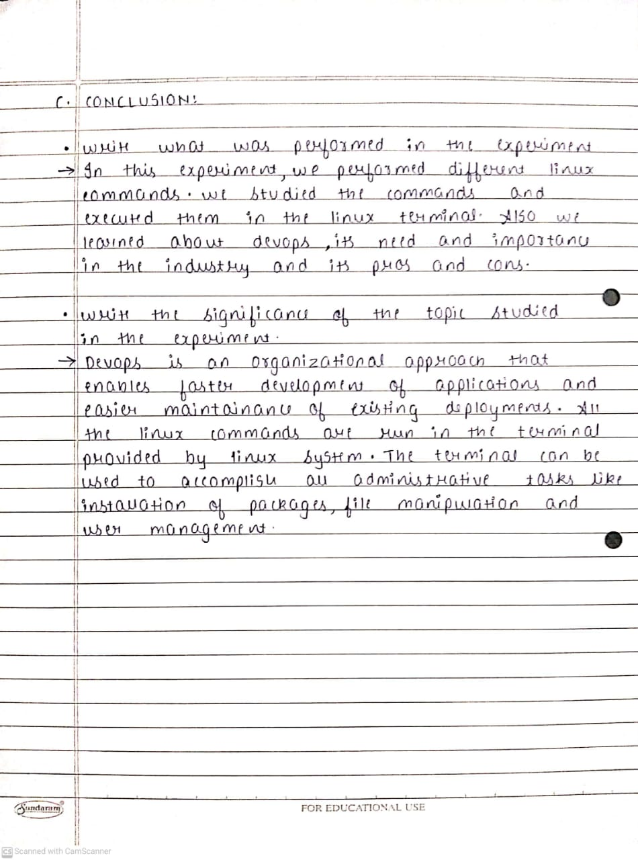

1. **References:**

* <https://www.edureka.co/blog/interview-questions/linux-interview-questions-for-beginners/>
* https://www.softwaretestinghelp.com/devops-interview-question11
* <https://techlog360.com/basic-ubuntu-commands-terminal-shortcuts-linux-beginner/>
* https://tutorials.ubuntu.com/tutorial/command-line-for-beginners#0
* https://techlog360.com/basic-ubuntu-commands-terminal-shortcuts-linux-beginner/
* https://www.edureka.co/blog/top-10-devops-tools/
* https://www.guru99.com/devops-tutorial.html